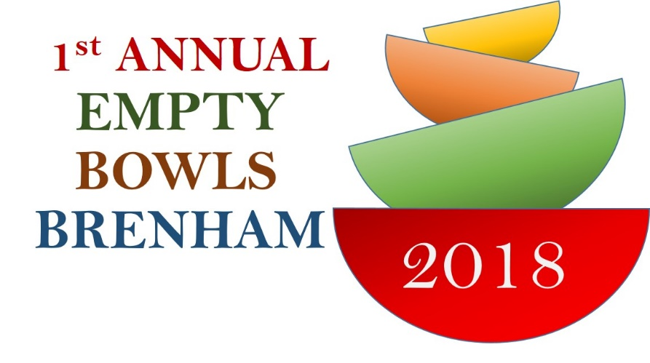
a
Empty Bowls Brenham - 2018
In-Kind Donation Form
Please note your donation is tax-deductible. Please complete and email this form to brenhamemptybowls@gmail.com

Questions? Please contact Vikram Iyer:
vikram.iyer@yahoo.com / (214)-308-1777

Business Name
Address
City/State/Zip
Home Phone |  |  |  |  | Cell Phone
Email
Website
Contact Name
Contact Email
Please indicate detail of donated items below:
 |  |  | Item Name |  | Quantity |  |  | Item Value ($)
1)
2)
3)
4)
5)
6)
7)
For logistics planning purposes, please specify which one of the following options apply to you:
 | We WILL bring the items to the event, set up and display
 | We WILL NOT deliver. We will need our items picked up.
 | Please note: Items should be ready for pick up by Thursday, November 1. Please indicate the name of a contact to assist on the day of pick-up
Contact Name |  |  |  | Business Phone |  |  |  | Cell Phone

Thank you for your support!

