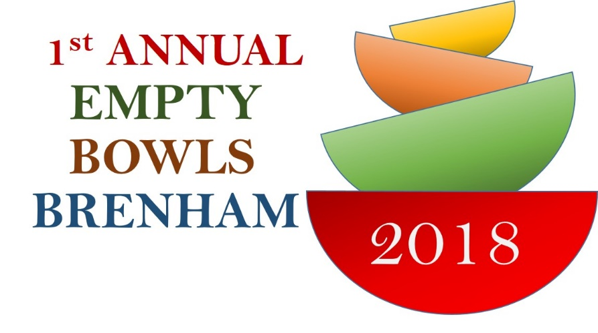
a
Empty Bowls Brenham - 2018
Soup Sponsor Reply Form
Please note your donation is tax-deductible. Please complete and email this form to brenhamemptybowls@gmail.com

Questions? Please contact Vikram Iyer:
vikram.iyer@yahoo.com / (214)-308-1777

Business Name
Address
City/State/Zip
Home Phone |  |  |  |  | Cell Phone
Email
Website
Contact Name
Contact Email
Name/Type of Soup
Soup Qty (in gallons)
Please check all that apply:  Vegan  Vegetarian  Gluten Free
For food allergy precautions, please indicate if your soup contains the following:
 Gluten  Peanuts  Milk  Shellfish  Soy  Eggs  Wheat  Tree Nuts
For logistics planning purposes, please specify which one of the following options apply to you:
 | We WILL bring the soup to the event, set up our soup and display, stay and serve our soup
 | Number of staff attending
 | We WILL deliver the soup to the event, but we can’t stay. We’ll need someone else to serve our soup.
 | Please note: All soup must be delivered to the event location between 10:00-10:30 a.m. on Friday, November 2 2018
 | We WILL NOT deliver or serve. We will need our soup picked up.
 | Please note: soup should be ready for pick up on Friday, November 2 before 9 AM. Please indicate the name of a contact to assist on the day of soup pick-up
Contact Name |  |  |  | Business Phone |  |  |  | Cell Phone

Thank you for your support!

